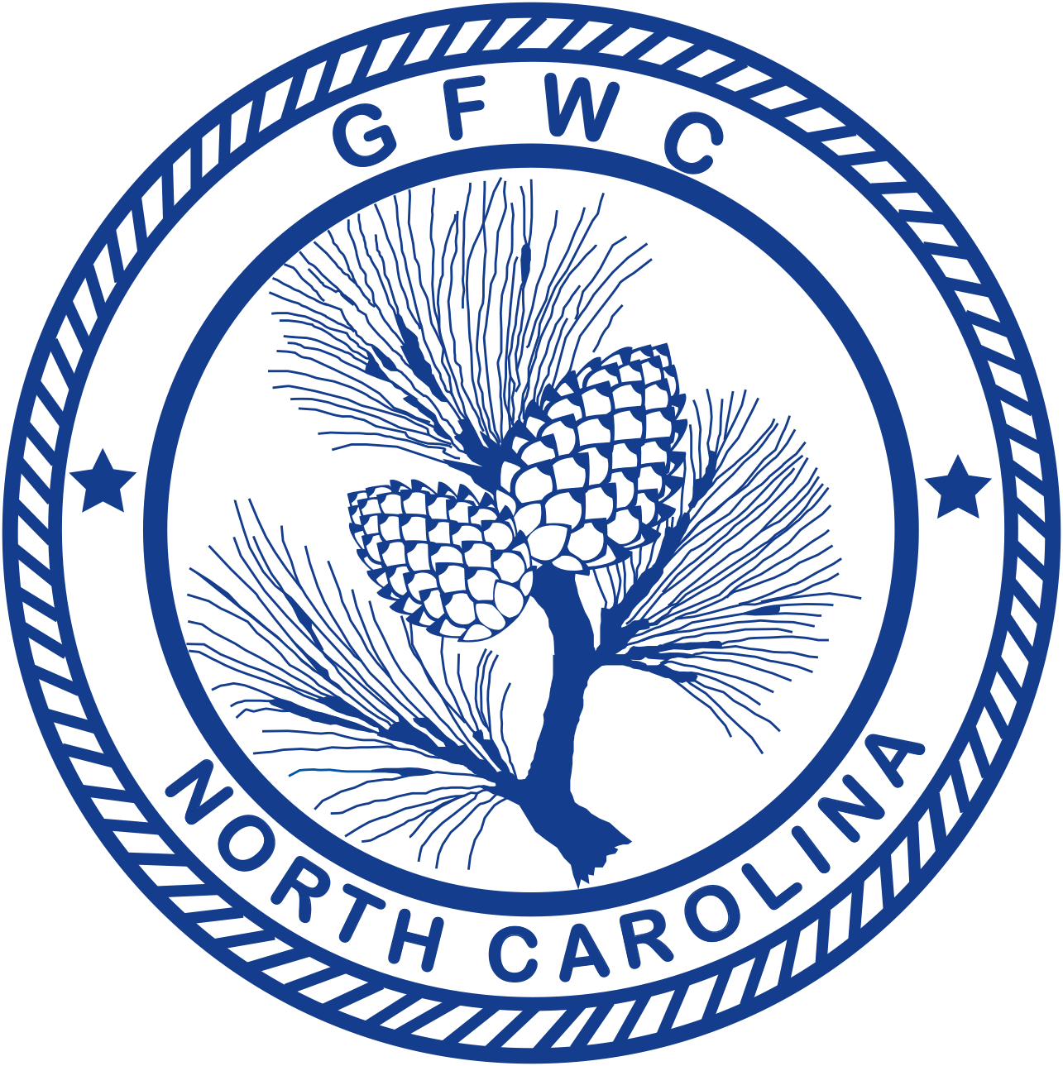 | General Federation of Women’s Clubs of North Carolina  2018-2020 International Outreach Community Service Program  Award Entry  (Please copy form for both reporting years of this administration)

Chairman | Junior Chairman | Juniorette Chairman
Vicki Currin  5109 Doughtymews Lane  Fuquay-Varina, NC 27526  Email: victoria.currin@hotmail.com  Cell Phone: 919-612-9547 | Misty Deyo  6029 Bur Trl.  Raleigh, NC 27616  Email: mistydeyo@gmail.com  Cell Phone: 919-272-5388 | Jennifer Smith  500 Poplar Station Circle NW, Apt. 108  Concord, NC 28027  Email: smithjen75@gmail.com  Cell Phone: 704-793-3513

Deadline: Midnight, February 1st
Postmarked or Emailed
Submit three (3) copies of the report to the appropriate Chairman

Club Name |  | General/Junior/Juniorette
Address/City |  | Total # of Members | District
Club President’s Name | Phone # | Email Address

GFWC Partnership Organizations:
- Heifer International | - United Nations Foundation, Shot@Life
- Operation Smile Foundation | - U.S. Fund for UNICEF

CLUB TOP 5 PROJECTS (only):
Project/Program | # Programs  & Projects | # Members Participating | Volunteer Hours | Dollars Donated | In-Kind Donations

CREATIVITY ENTRY: Choose one of your top five entries to be judged for the Club Creativity Project.

CREATIVE PROJECT:

Award Entry Instructions:
- List ONLY your top FIVE (5) projects and/or programs held in this CSP area.
- Choose ONE project or program for the Club Creativity Award Entry. This entry will be judged in addition to the CSP Award Entry. A General, Junior and Juniorettee winner will be chosen. The CSP Club Creativity Award Entry replaces the Partnership Award Entry.
- Include any facts which you consider vital to the reader’s understanding of your project
- Include information that tells the story and answers the questions: Who? What? Where? Why? How?
- Include statistics for each project and/or program area
- Number of members participated cannot exceed the total club membership
- Include information about the impact of your project upon the community and list other community groups involved
- Keep one copy of this report for your club’s files
- Award Entry Narratives are limited to three (3) additional pages, single spaced, no less than 10pt type.
- Separately – total ALL your club projects/programs, hours, dollars and number of members in this CSP for entry on the CP&S Form.
- All entries must be submitted by email OR postmarked by midnight, February 1st.

