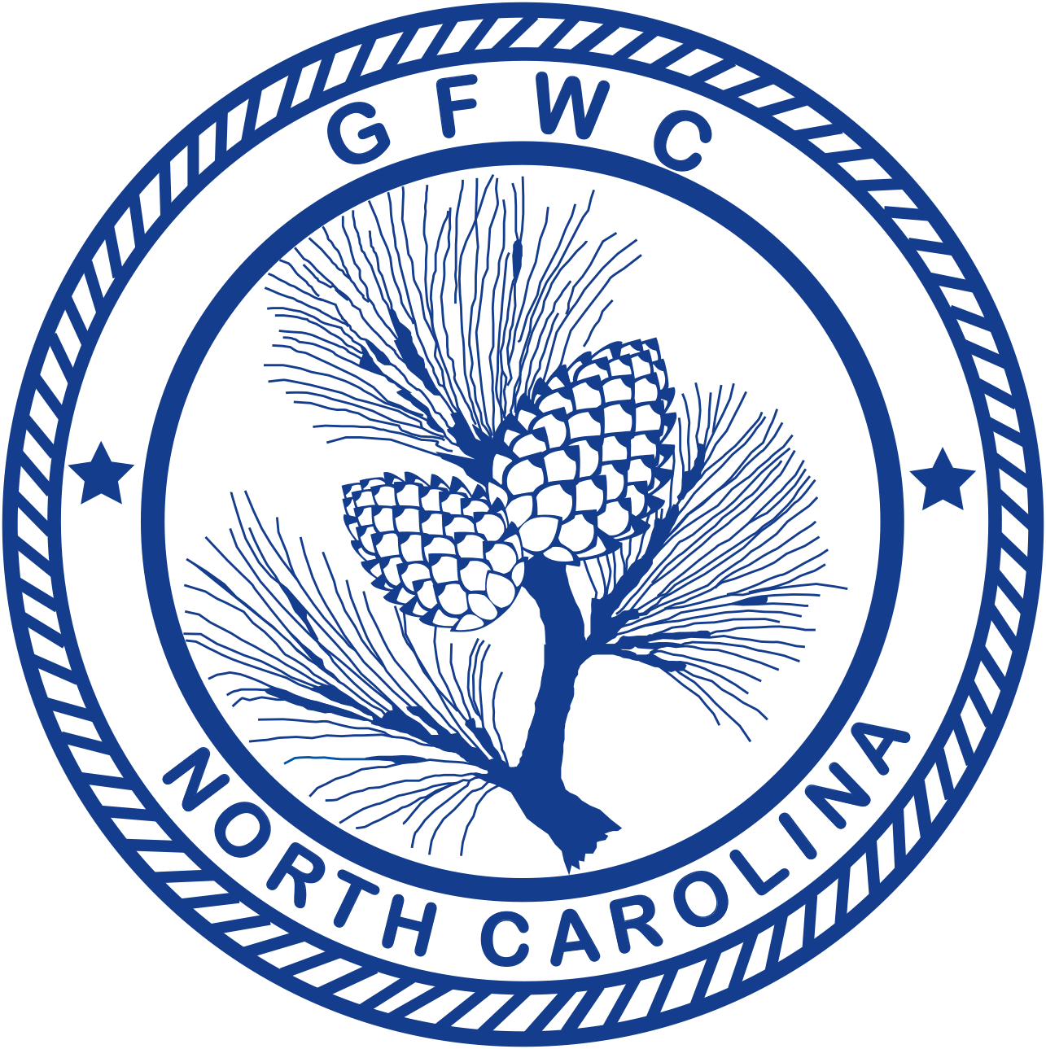 | General Federation of Women’s Clubs of North Carolina  2018-2020 Membership Cooperation & Involvement  Award Entry Narrative  (Please copy form for both reporting years of this administration) | 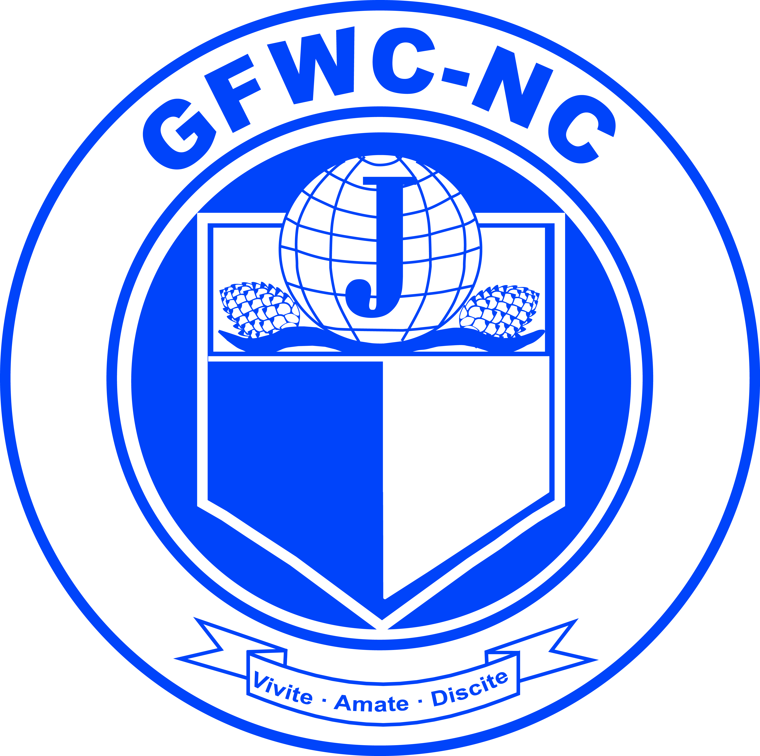

General Club entries to:  Crystal O'Neal, President-elect  P.O. Box 1382  Graham, NC 27253  Email: crystalncjuniors@gmail.com  Office: 336-570-6711 Ext-206  Cell Phone: 336-212-0649 | Junior Club entries to:  Angela Moss, Director-elect of Junior Clubs  26 Smithwood Dr  Fuquay-Varina, NC 27526  Email: angelamoss3@aol.com  Cell Phone: 919-291-7004

Deadline: MIDNIGHT, February 1st
Postmarked or Emailed
Submit three (3) copies of this Entry Form and your Narrative to the correct Chairman listed above.

Club Name |  | General/Junior
Address/City |  | Total # of Members | District
Club President’s Name | Phone # | Email Address

Awarded to the club, which most effectively stimulates the cooperative involvement of its members in working together to carry out the objectives of the local club and in line with the current program of GFWC-NC. (formerly known as “Effective Involvement of Members”)
Rules for General and Junior:
- Each entry shall include this cover sheet and a narrative of up to a maximum of ten (10) pages of the club’s programs and projects for the prior calendar year.
- Include the number of members and percentage of members actively involved and extent of involvement.
- List the work for improvements and/or accomplishments in club members’ relationships.
- List definitive efforts to develop better group work within the club in the period covered and the total number of hours involved and total donations.
- List community service programs active in the club.

