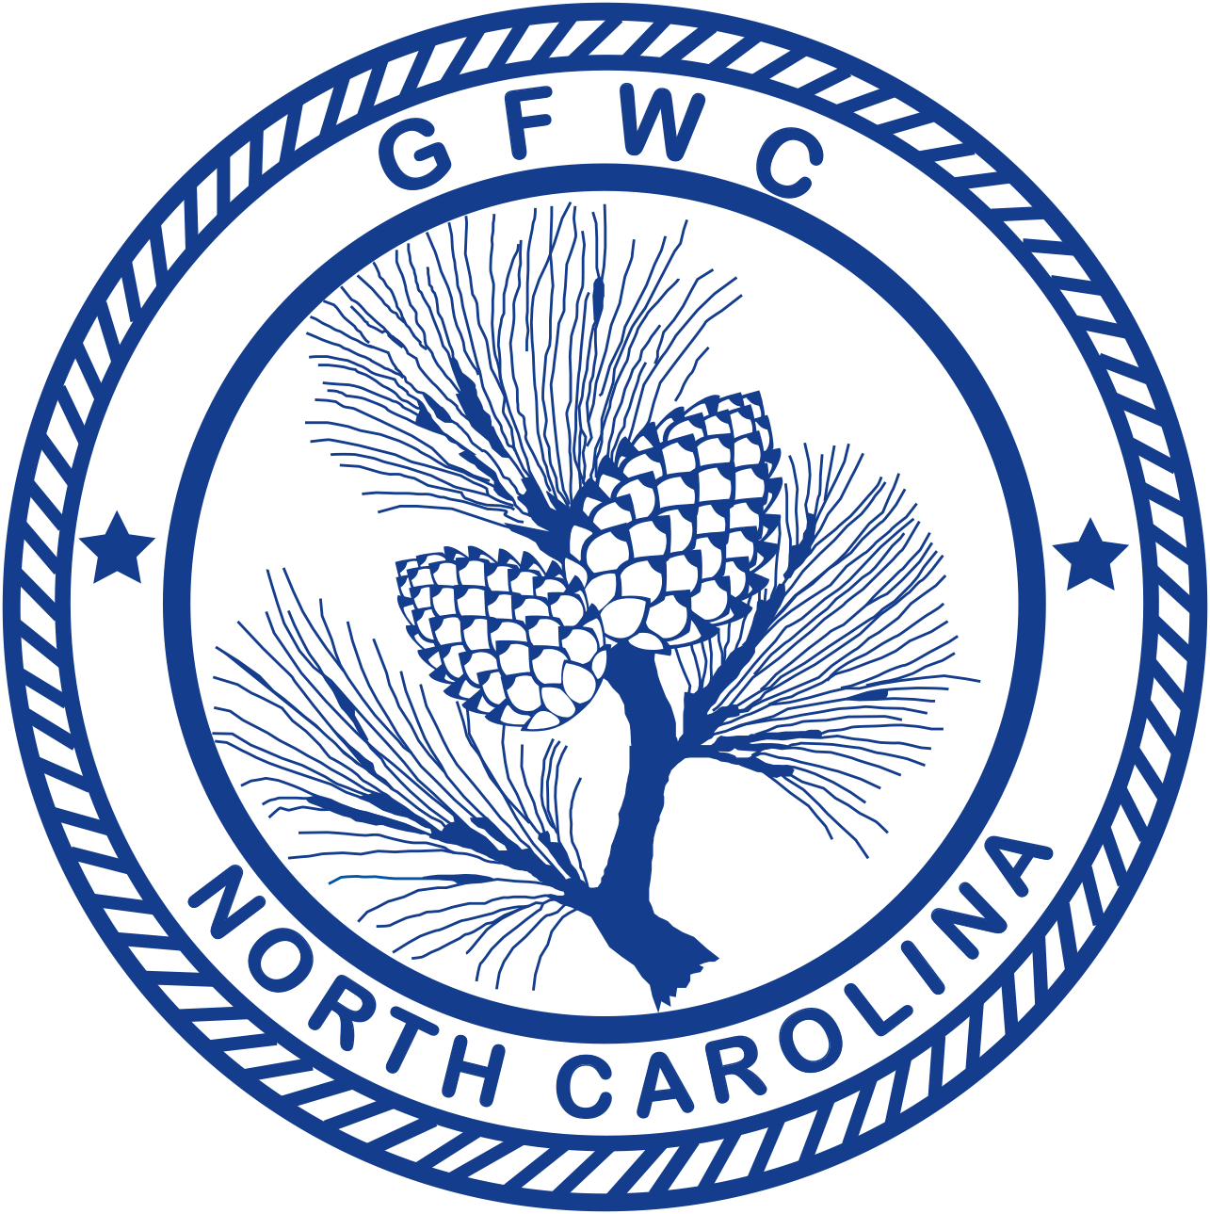 | General Federation of Women’s Clubs of North Carolina  GFWC-NC Leadership  Award Entry Narrative  (Please copy form for both reporting years of this administration) | 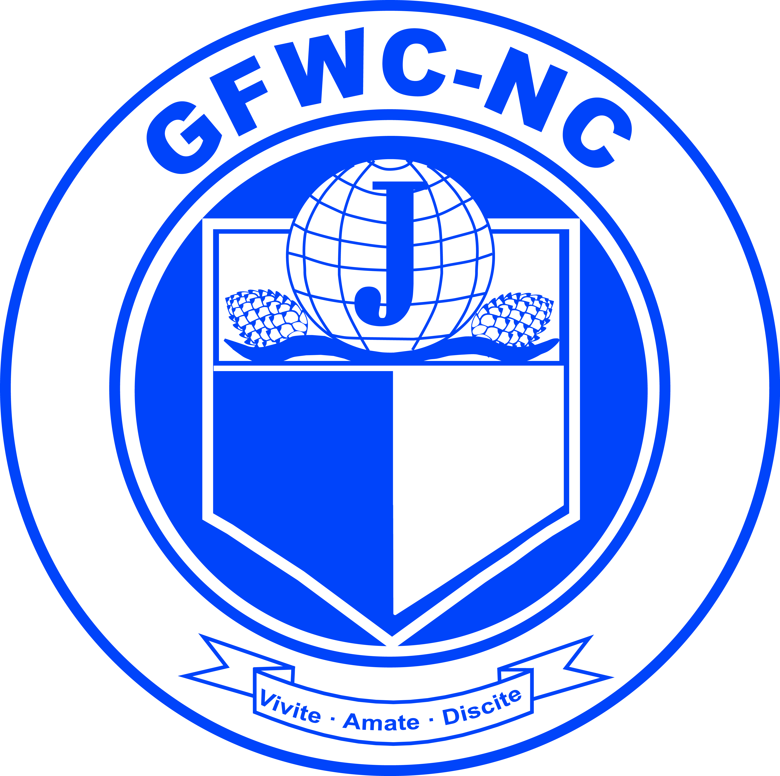

Jan Allen, Chairman  8532 N Shoreside Way, Leland, NC 28451  Phone: 910-899-7444  Email: jaa8532@gmail.com | Deadline: MIDNIGHT, February 1st  Postmarked or Emailed  Submit three (3) copies of this Entry Form and your Narrative to the Chairman

Club Name |  | General/Junior
Address/City |  | Total # of Members | District
Club President’s Name | Phone # | Email Address
CLUB TOP 5 PROJECTS (only):
Project/Program | # Programs  & Projects | # Members Participating | Volunteer Hours | Dollars Donated | In-Kind Donations

CREATIVITY ENTRY: Choose one of your top five entries to be judged for the Club Creativity Project.
CREATIVE PROJECT:

Award Entry Instructions:
Awarded to the club (General and Junior) reporting the best overall work on Leadership Development.
- List (up to but no more than) your top FIVE (5) projects and/or programs held in this program area.
- Choose ONE project or program for the Club Creativity Project Award Entry.
- (1) overall winner and (1) creative winner will be chosen.
- Include any facts (INCLUDE A SHORT SENTENCE THAT TELLS THE STORY AND ANSWERS THE QUESTIONS: WHO? WHAT? WHERE? WHY? HOW?) which you consider vital to the reader’s understanding of your project. Include statistics for each project. Consider including information about the impact of your project upon the community and list other community groups involved. Begin your report below. Keep one copy of this report for your club’s files.
- Entry narrative is limited to three (3) single-spaced typewritten pages (8 1/2 X11) using 10-point font.
- Number of members participating cannot exceed total club membership.
- Report totals on CP&S Form, totals should match.

Project | # Members Participating | Volunteer Hours | Dollars Donated | In-Kind Donations | Narrative Included?
Sponsored LEADS Candidate
Member subscriptions to GFWC Magazine
Member subscriptions to GFWC
e-newsletter
Members attended District Meetings
Members attended State Meetings (Summer, Arts, Convention, Fall Conference)
Members attended Southeastern Regional Meeting (SER)
Members attended GFWC Convention
Administrative Duties for Club/GFWC-NC/GFWC

