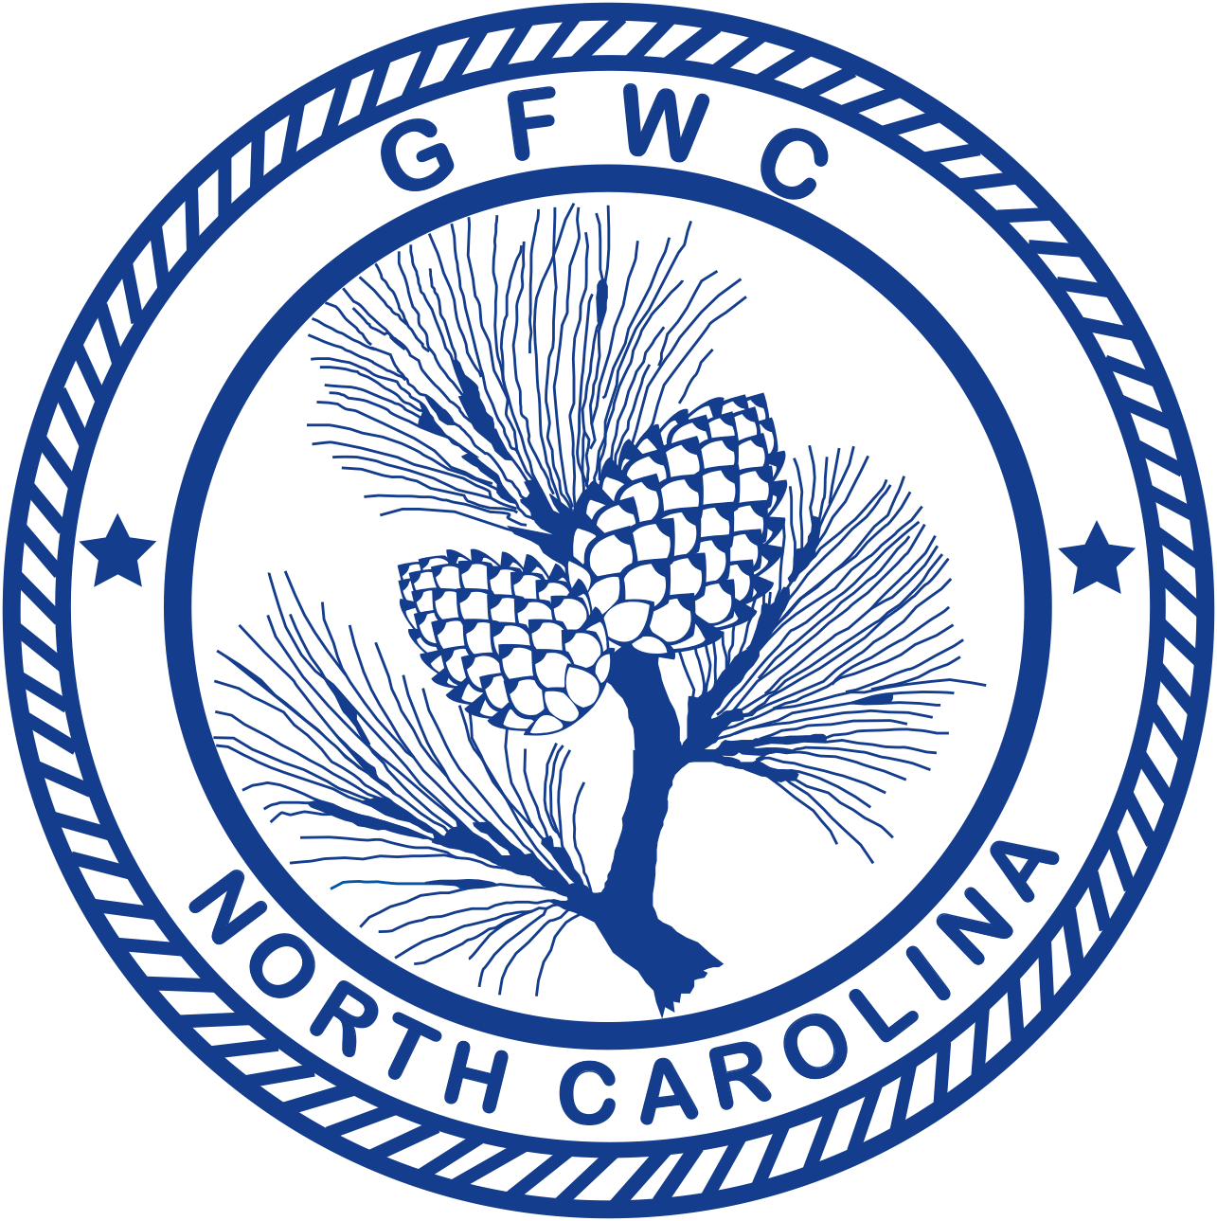 | General Federation of Women’s Clubs of North Carolina  2018-2020 Juniorettes  Award Entry Narrative  (Please copy form for both reporting years of this administration) | 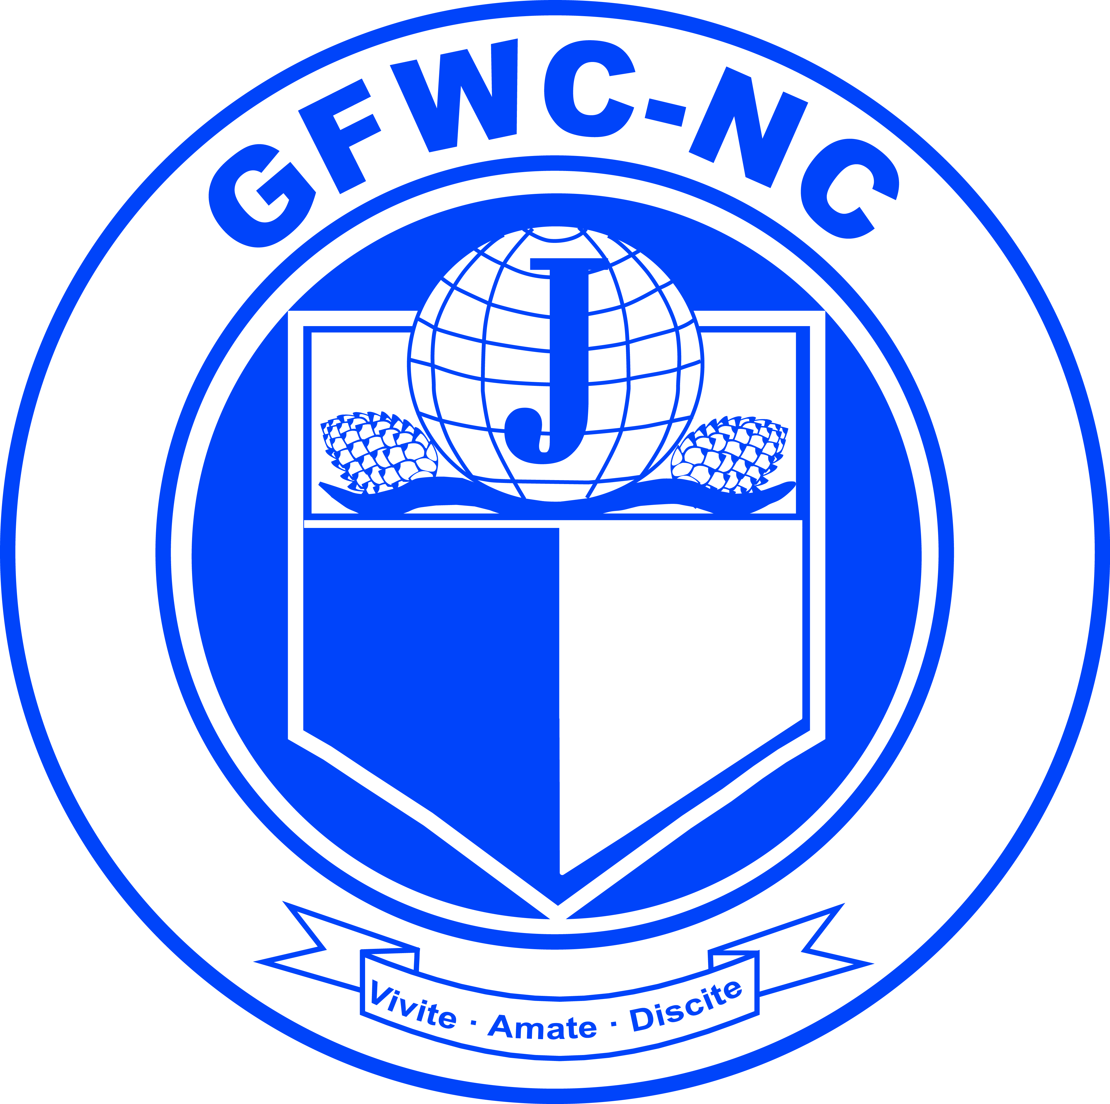

Jennifer Smith, Chairman  500 Poplar Station Circle NW, Apt. 108  Concord, NC 28027  Phone: 704-793-3513 Email: smithjen75@gmail.com | Deadline: MIDNIGHT, February 1st  Postmarked or Emailed  Submit three (3) copies of this Entry Form and your Narrative to the Chairman

Club Name |  | General/Junior
Address/City |  | Total # of Members | District
Club President’s Name | Phone # | Email Address

Award Entry Instructions:
Awarded to the club (General and Junior) reporting the best overall work with Juniorettes.
- Include any facts that you consider vital to the reader’s understanding of your project.
- Include information that tells the story and answers the questions: Who? What? Where? Why? How?
- Include statistics for each project and/or program area.
- Number of members participated cannot exceed the total club membership.
- Include information about the impact of your project upon the community and list other community groups involved.
- Entry narrative is limited to two (2) additional single-spaced typewritten pages (8 1/2 X11) using 10-point font.
Total # of Programs/Projects | # of Members Participating | Total Volunteer Hours | Total Dollars Donated | Total In-Kind Donations

