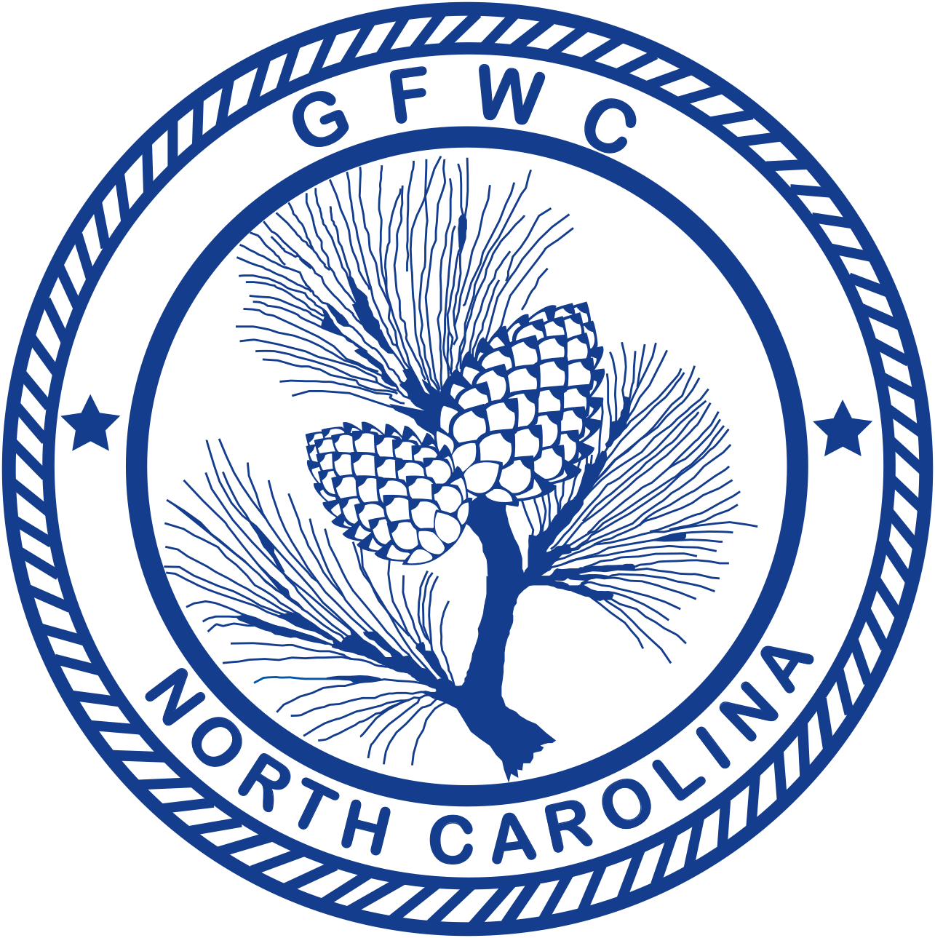 | General Federation of Women’s Clubs of North Carolina  Federation Day  Award Entry Narrative  (Please copy form for both reporting years of this administration)

Pauletta Parker, Chairman  135 Fox Run Drive, Wilkesboro, NC 28697  Phone 336-838-5332  Email: parkerpr62@gmail.com | Deadline: Midnight, February 1st  Postmarked or Emailed  Submit three (3) copies of this Entry Form and your Narrative to the Chairman

Club Name |  | General/Junior
Address/City |  | Total # of Members | District
Club President’s Name | Phone # | Email Address

CLUB TOP 5 PROJECTS (only):
Project/Program | # Programs  & Projects | # Members Participating | Volunteer Hours | Dollars Donated | In-Kind Donations

Award Entry Instructions:

The Federation Day Observance is officially April 24 with April as GFWC emphasis month. Please report any observance a club may carry out during the month of April, whether events, programs and/or projects. Media coverage clippings, snapshots and programs may accompany a three-page report. All clubs entering for the Federation Day Award must send their entry to the State Federation Day Chairman by February 1st.
- Clubs may also submit to their District Federation Day Contest provided their District offers it. Rules for District entries will be provided by the District.
- List (up to but no more than) your top FIVE (5) projects and/or programs held in this program area.
- Work can be done in any or all community service programs.
- Include any facts which you consider vital to the reader’s understanding of your project.
- Include information that tells the story and answers the questions: Who? What? Where? Why? How?
- Include statistics for each project and/or program area.
- Number of members participated cannot exceed the total club membership.
- Include information about the impact of your project upon the community and list other community groups involved.
- Entry narrative is limited to two (2) additional single-spaced typewritten pages (8 1/2 X11) using 10-point font.

