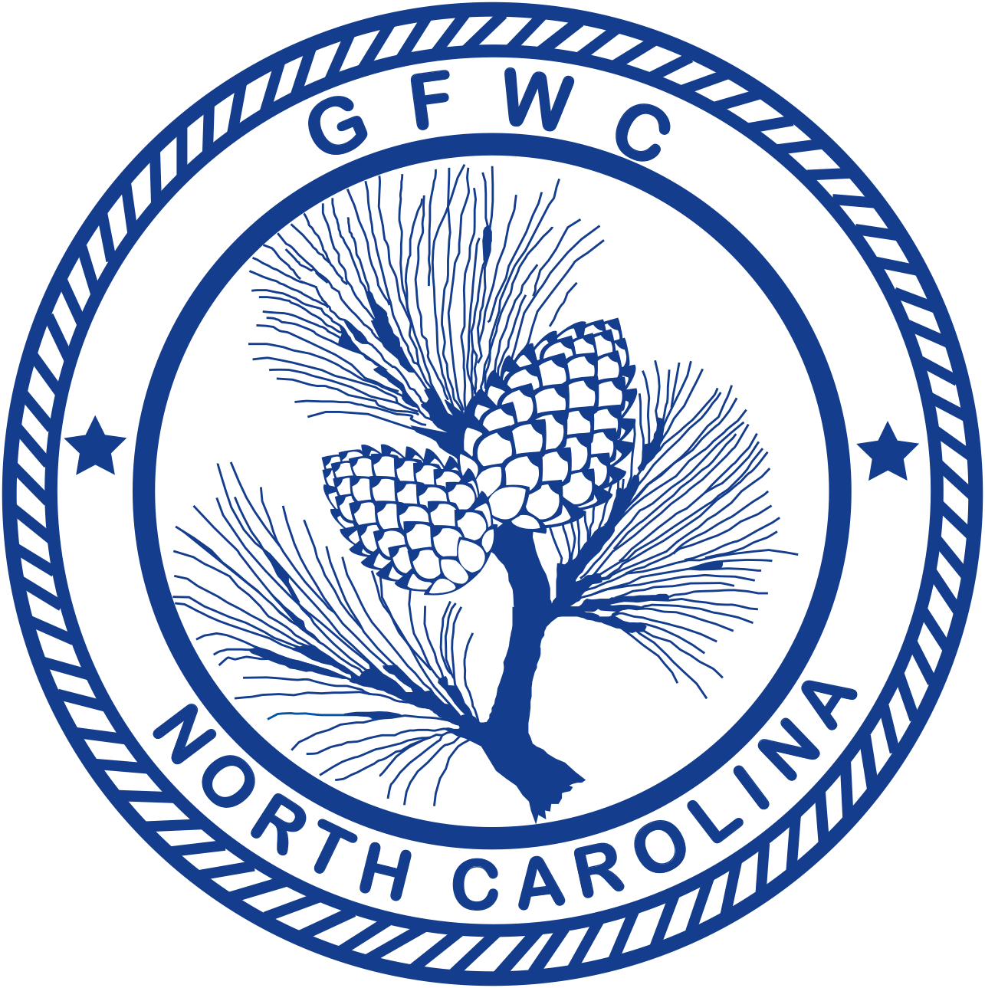 | General Federation of Women’s Clubs of North Carolina  ESO  Award Entry Narrative  (Please copy form for both reporting years of this administration)

Julie Rigsbee, Chairman  4111 Vann Dr., Lumberton, NC 28358  Home: 910-738-7593 Cell: 910-827-0396  Email: drigsbee@nc.rr.com | Deadline: MIDNIGHT, February 1st  Postmarked or Emailed  Submit three (3) copies of this Entry Form and your Narrative to the Chairman

Club Name |  | General/Junior
Address/City |  | Total # of Members | District
Club President’s Name | Phone # | Email Address

The Faye Hoffman ESO Award is given to the club (General and Junior) with the best overall participation in ESO.
- Entry narrative is limited to 2 additional single-spaced typewritten pages (8 1/2 X11) using 10-point font.
- Number of members participating cannot exceed total club membership
- Report totals on CP&S Form, totals should match.

Total # of Programs/Projects | # of Members Participating | Total Volunteer Hours | Total Dollars Donated | Total In-Kind Donations

Top of Form
Does your club have an ESO Chairman? | ___ Yes ___ No
How many members are active participants in ESO (Active means they have submitted an ESO report to the ESO Chairman in the prior club year)
How many members reached a new ESO Level?
How many new ESO members has your club recruited?
Bottom of Form

What has your club done to promote ESO within your club?

