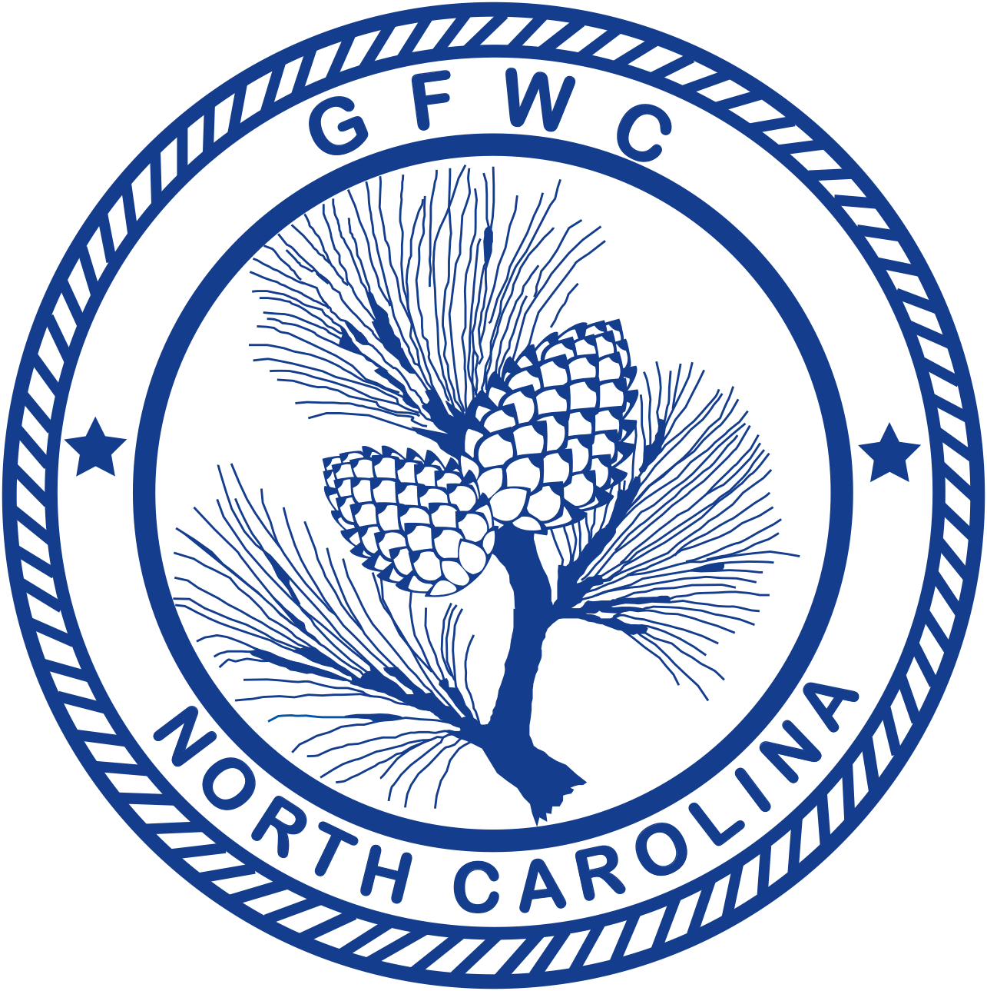 | General Federation of Women’s Clubs of North Carolina  Drug Education  Award Entry Narrative  (Please copy form for both reporting years of this administration)

Noreen Welch, Chairman  17 Skyline Road, Southern Shores, NC 27949  Phone 252-216-9455  Email: noreenw999@yahoo.com | Deadline: Midnight, February 1st  Postmarked or Emailed  Submit three (3) copies of this Entry Form and your Narrative to the Chairman

Club Name |  | General/Junior
Address/City |  | Total # of Members | District
Club President’s Name | Phone # | Email Address

Total # of Programs/Projects | # of Members Participating | Total Volunteer Hours | Total Dollars Donated | Total In-Kind Donations

Award Entry Instructions:
Katy Hauser Grubbs Pitcher, Katy Hauser Grubbs, donor. Awarded to the club (General or Junior) reporting the most effective programs in Drug Awareness Education, Kindergarten through Grade 12 as well as adult education.

- Only one award is given. There is no Creativity Project judged for the award entry.
- Work can be done in any or all community service programs.
- Include any facts which you consider vital to the reader’s understanding of your project.
- Include information that tells the story and answers the questions: Who? What? Where? Why? How?
- Include statistics for each project and/or program area.
- Number of members participated cannot exceed the total club membership.
- Include information about the impact of your project upon the community and list other community groups involved.
- Entry narrative is limited to two (2) additional single-spaced typewritten pages (8 1/2 X11) using 10-point font.

