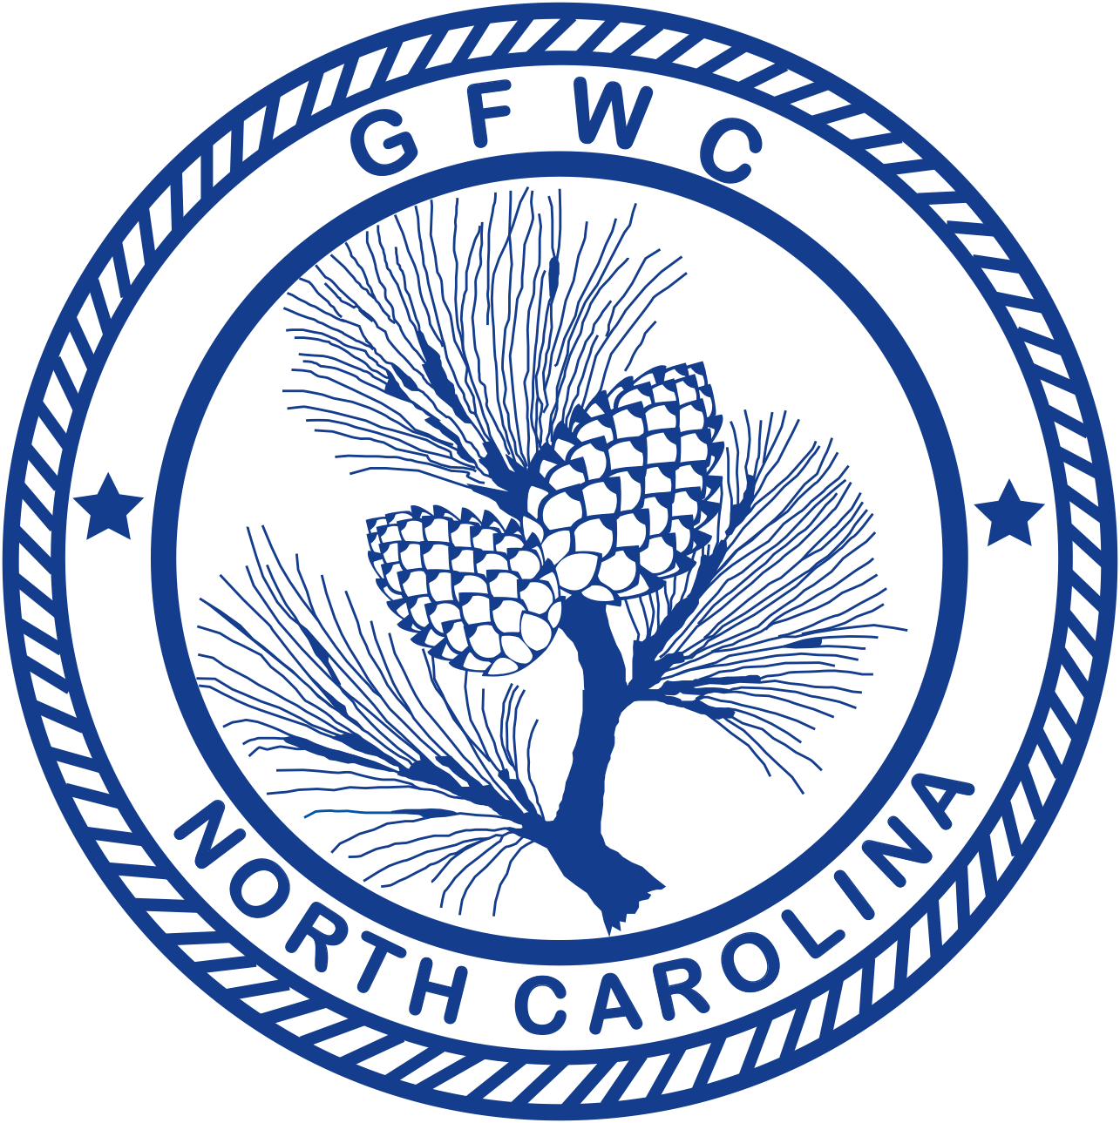 | General Federation of Women’s Clubs of North Carolina  2018-2020 GFWC Signature Program:  Domestic Violence Awareness & Prevention  Award Entry Narrative  (Please copy form for both reporting years of this administration)

Lori Seiler, Chairman  PO Box 430, Alamance, NC 27201  Phone: 336-212-0758 Email: panthers@bellsouth.net | Deadline: MIDNIGHT, February 1st  Postmarked or Emailed  Submit three (3) copies of this Entry Form and your Narrative to the Chairman

Club Name |  | General/Junior
Address/City |  | Total # of Members | District
Club President’s Name | Phone # | Email Address

CLUB TOP 5 PROJECTS (only):
Project/Program | # Programs  & Projects | # Members Participating | Volunteer Hours | Dollars Donated | In-Kind Donations

CREATIVITY ENTRY: Choose one of your top five entries to be judged for the Club Creativity Project.

CREATIVE PROJECT:

Award Entry Instructions:
Awarded to the club (General and Junior) reporting the best overall work on the GFWC Signature Project, Domestic Violence Awareness and Prevention
- List (up to but no more than) your top FIVE (5) projects and/or programs held in this program area.
- Choose ONE project or program for the Club Creativity Project Award Entry. This entry will be judged in addition to the Overall Award Entry.
- (1) overall winner and (1) creative winner will be chosen.
- Include information about the impact of your project upon the community and list other community groups involved.
- Include information that tells the story and answers the questions: Who? What? Where? Why? How?
- Include statistics for each project and/or program area.
- Keep one copy of this report for your club’s files.
- Award Entry Narratives are limited to three (3) additional pages, single-spaced, no less than 10pt type.
- Separately – total ALL your club projects/programs, hours, dollars and number of members in this program for entry on the CP&S Form.

