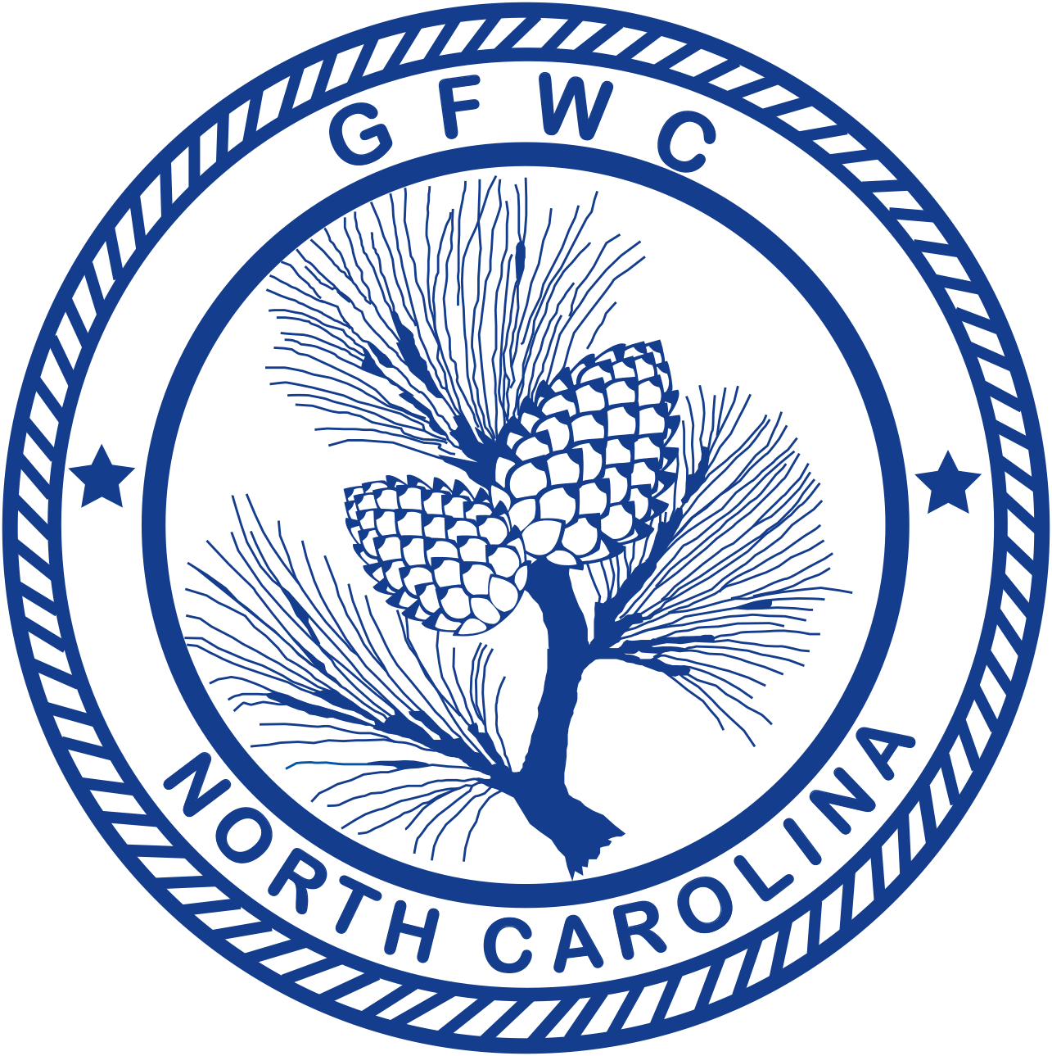 | General Federation of Women’s Clubs of North Carolina  2018-2020 GFWC-NC Communications and Public Relations  Award Entry  Page 1 of 2  (Please copy form for both reporting years of this administration)

Jennifer Nelson, Chairman  6744 Wheeler Dr., Charlotte, NC 28211  Cell Phone: 207-232-6252  maineiacrunner@gmail.com | Deadline: MIDNIGHT, February 1st  Postmarked or Emailed  Submit three (3) copies of this Entry Form and your Narrative to the Chairman

Club Name |  | General/Junior
Address/City |  | Total # of Club Members | District
Club President’s Name | Phone # | Email Address

CLUB TOP 5 PROJECTS (only):
Project/Program | # Programs  & Projects | # Members Participating | Volunteer Hours | Dollars Donated | In-Kind Donations

CREATIVITY ENTRY: Choose one of your top five entries to be judged for the Club Creativity Project.

CREATIVE PROJECT:

Award Entry Instructions:
The Elizabeth Huntley Maddrey Tray (donor) is awarded to the club (General or Junior) whose entry best meets the award criteria and reports the most effective program in communications and/or public relations, implementing the tools for proper communication, public awareness and public relations. See Judges Criteria for additional information. Narratives submitted (not to exceed three (3) pages) should support the criteria listed below. Copies of a one issue of a newsletter and a membership brochure may be included and are in addition to the narrative.
- List (up to but no more than) your top FIVE (5) projects and/or programs held in this program area.
- Choose ONE project or program for the Club Creativity Project Award Entry. This entry will be judged in addition to the Overall Award Entry.
- (1) overall winner and (1) creative winner will be chosen.
- Include information about the impact of your project upon the community and list other community groups involved.
- Include specific information detailing the effectiveness of these efforts (examples: number of members who participated, number of new members recruited, special awards received, website hits, “likes,” etc.)
- You may combine information into a Program, such as Club materials (brochure, newsletter, yearbook); Social Media (Twitter, Facebook, Instagram).
- Copies of a one issue of a newsletter and a membership brochure may be included and are in addition to the narrative.
- Keep one copy of this report for your club’s files.
- Award Entry Narratives are limited to three (3) additional pages, single-spaced, no less than 10pt type.
- Separately – total ALL your club projects/programs, hours, dollars and number of members in this program for entry on the CP&S Form.

General Federation of Women’s Clubs of North Carolina
2018-2020 GFWC-NC Communications and Public Relations
Award Entry
Page 2 of 2
(Please copy form for both reporting years of this administration)

Jennifer Nelson, Chairman  6744 Wheeler Dr., Charlotte, NC 28211  Cell Phone: 207-232-6252  maineiacrunner@gmail.com | Deadline: MIDNIGHT, February 1st  Postmarked or Emailed  Submit three (3) copies of this Entry Form and your Narrative to the Chairman

Club Name | General/Junior

(leave this area blank – to be completed by judges)
Judges Criteria: | Possible Points | Points Awarded
- Club Materials:  - membership brochure, include a copy  - Connection to GFWC-NC and GFWC  - Content – such as: Club purpose, Club Programs & Projects, Membership information, Membership benefits, Club history  - club newsletters, you may include a copy, no more than one newsletter  - General Information - Identification, date of issue, name and mailing address of President and/or Editor.  - Content - President’s message, notice of meeting, program agenda, CSP news, club activities, Member recognition, personal news, humor, quotes, inspiration.  - club yearbook, include a description of your yearbook – and what it contains | 15
- Sharing of Federation news: GFWC / GFWC-NC / District | 10
- Community PR/General information about the club’s communications & public relations programs – such as:  - Broadcast/print media/advertising (EX press releases, public service announcements, newspaper or magazine articles, television, radio)  - Technology/Internet (EX: club website, email, social networking such as Facebook or Twitter, Instagram etc.)  - Visibility in the community (EX: joint projects with other organizations, club t-shirts, banners, social receptions or other events in community)  - Other / Unique communication and public relation programs | 40
- Information regarding the effectiveness of club’s programs – such as:  - % members who participate  - Increase in membership  - Fund-raising successes  - Website “hits”  - Other (EX: special awards received) | 25
- Overall presentation - quality and readability of narrative report | 10
 | TOTAL: | _____

