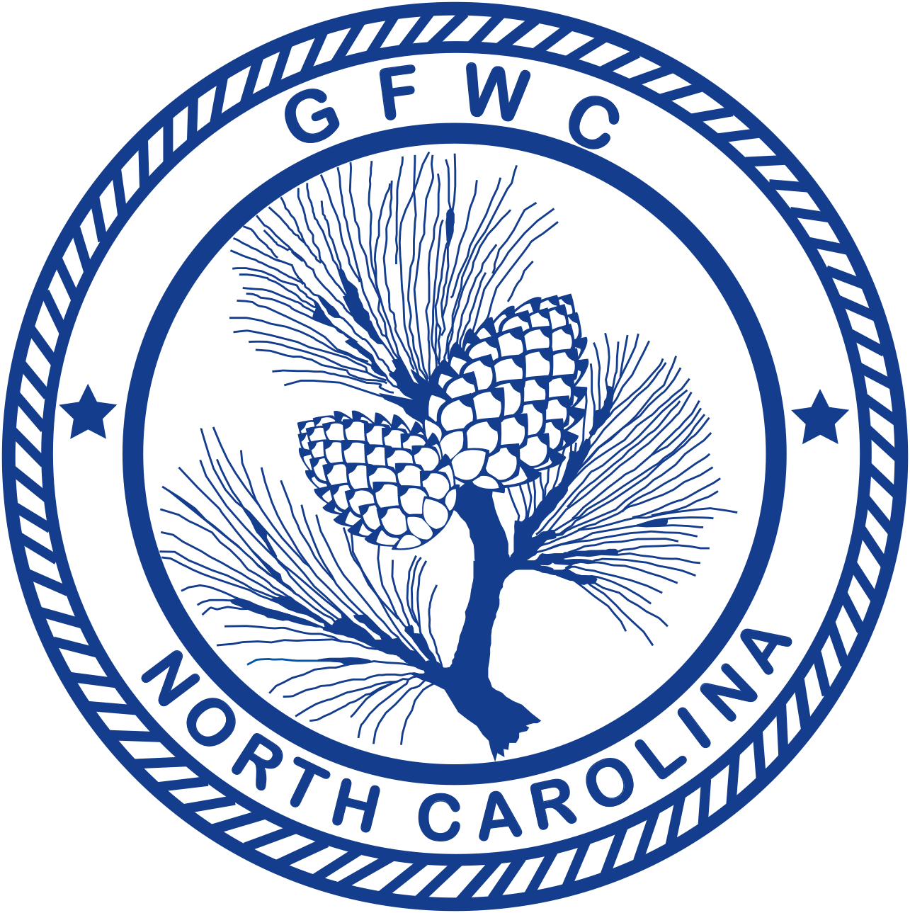 | General Federation of Women’s Clubs of North Carolina  2018-2020 Community Improvement Program  Award Entry Narrative  (Please copy form for both reporting years of this administration) | 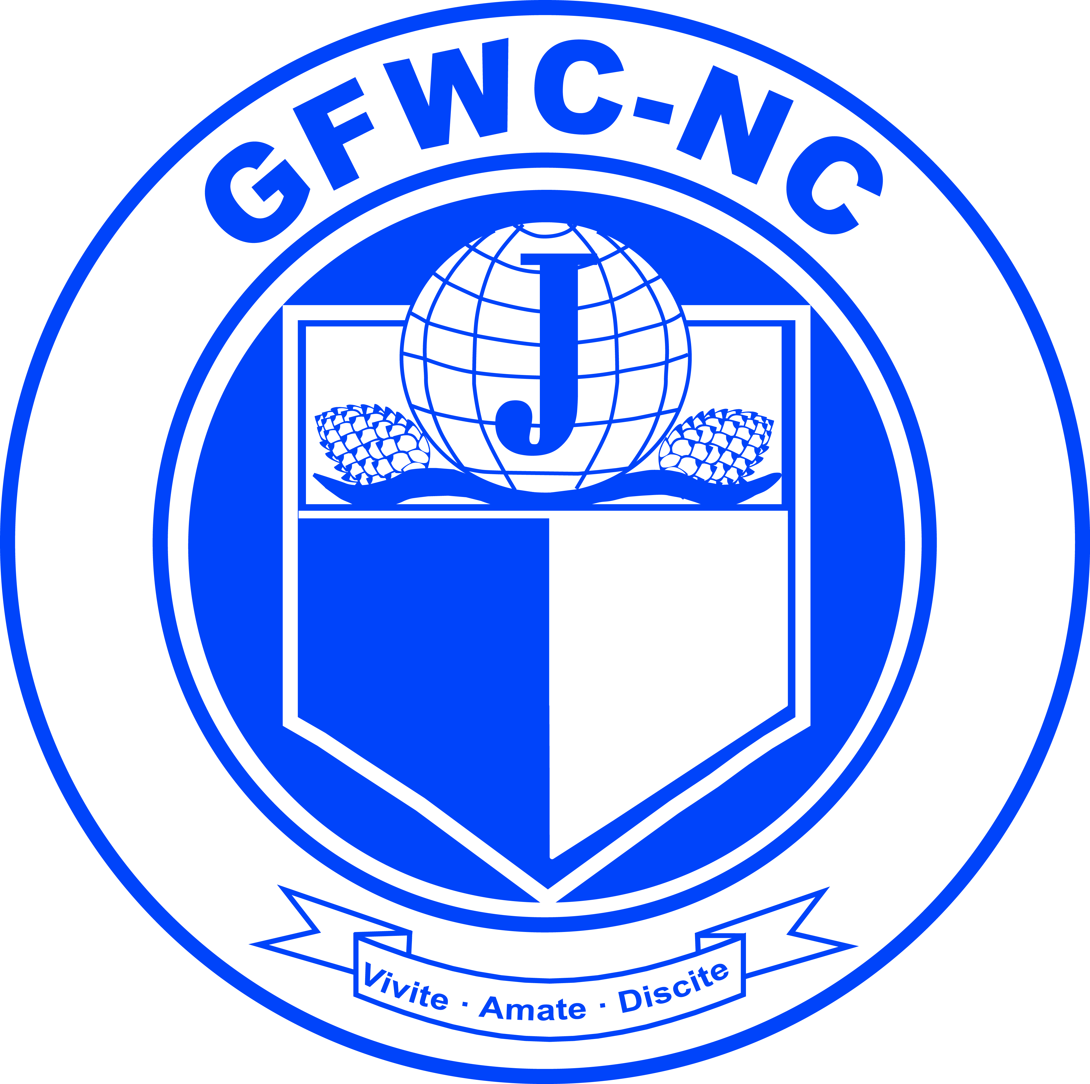

Helen Richie, 1st Vice President  12446 Woodbend Drive, Matthews NC 28105  Phone: 704-577-2763  Email: helenrichie@gmail.com | Deadline: MIDNIGHT, February 1st  Submitted in the Even year ONLY  Postmarked or Emailed  Submit three (3) copies of this Entry Form and your Narrative to the Chairman

Club Name |  | General/Junior
Address/City |  | Total # of Members | District
Club President’s Name | Phone # | Email Address

The Community Improvement Program Award provides clubs with the recognition for projects that meet the varying needs of their communities. Every two (2) years, a GFWC-NC award goes to the club (General, Junior and Juniorette) that is judged to have done the best project in making their community a better place to live.

- During even years, state winners are selected for the best work on a project over a two-year period (March 1 to April 30 two years later).
- A first, second, and third place winner is chosen and they receive cash awards. The first place winner’s award entry is sent to GFWC to compete in the GFWC Community Improvement Program Award which covers work done during the two-year administration.
- Clubs can work together on projects (as many as six). The GFWC Community Improvement Program Award Entry Form must be submitted accompanied by a narrative and supporting materials. Entry cannot weigh more than seven pounds nor measure more than 15” x 20” in size.
- For the submission of this award entry, GFWC guidelines and deadlines will apply. See the Community Improvement Program section in the GFWC Club Manual for more information.

Total # of Programs/Projects | # of Members Participating | Total Volunteer Hours | Total Dollars Donated | Total In-Kind Donations

