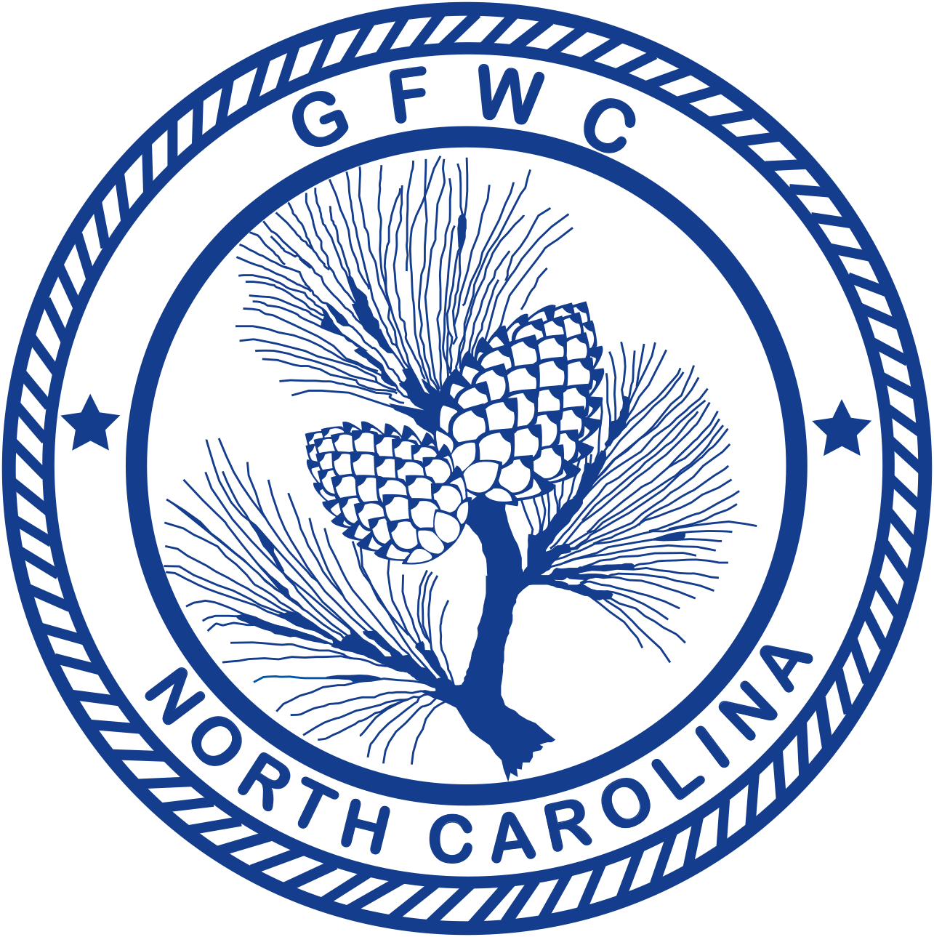 | General Federation of Women’s Clubs of North Carolina  2018-2020 Boys & Girls Home  Award Entry Narrative  (Please copy form for both reporting years of this administration)

Caroline Galen, Chairman  2884 Andrews Dr., SW, Supply 28462  Phone 910-842-2854  Email: caroline.galan@gmail.com | Deadline: MIDNIGHT, February 1st  Postmarked or Emailed  Submit three (3) copies of this Entry Form and your Narrative to the Chairman

Club Name |  | General/Junior
Address/City |  | Total # of Members | District
Club President’s Name | Phone # | Email Address

Total # of Programs/Projects | # of Members Participating | Total Volunteer Hours | Total Dollars Donated | Total In-Kind Donations

Award Entry Instructions:

The Ann Wheeler Brown Silver Tray, is given to the club reporting the best overall work done for Boys and Girls Homes of North Carolina (B&GH). Work can be done in any or all community service programs.
- Include information about the impact of your project upon the community and list other community groups involved.
- Include information that tells the story and answers the questions: Who? What? Where? Why? How?
- Include statistics for each project and/or program area.
- Keep one copy of this report for your club’s files.
- Award Entry Narratives are limited to two (2) additional pages, single-spaced, no less than 10pt type.
- Separately – total ALL your club projects/programs, hours, dollars and number of members in this program for entry on the CP&S Form.

